Hans-Bernd Zöllner: Strange Friends – Some Personal Reflections
According to my memory, at the initial meeting of the group of German editors, the first echo to the collection of mini-biographies received from the Judson Research Centre sounded like this: „Very far-away texts for the German taste; how will we be able to make the book readable in an attractive manner?“ I remember to have thought spontaneously that such strangeness was normal given the different worlds of Myanmar and Germany. And I had thought that a booklet on Christians in the Asian country should expose such strangeness and not try to harmonise.
1 Personal Memories
This reaction of mine was the result of my long-time experience which began with my first visit to the country in 1984 that was still called Burma then. At that time, I served as the pastor of the German Speaking Protestant Congregation in Thailand. To look after the Germans living in Burma and to contact the indigenous churches, was part of my assignment.
At that time, the country had been isolated from the rest of the world for some 22 years after the military leadership had introduced a „Burmese Way to Socialism“, which was after a coup that had toppled an elected government in 1962. Foreign influence had been drastically reduced in the years following the takeover by the military, including the expulsion of foreign missionaries. Burma followed a strict course of independence and self-reliance both in her foreign and international policies.
However, in terms of economic cooperation and development assistance , Germany – to be precise: both East and West Germany in very different ways – together with Japan was a close friend. This friendship was expressed by the West German President Richard von Weizsäcker when he visited Burma in 1986. Two years later it turned out that West Germany, my country, despite its good relations – the Burmese strongman Ne Win used to pay a visit to West Germany almost every year since 1962 – like the rest of the world, had not quite understood what was happening in that alien country praised for its Buddhist charm by West German officials, and for its socialist endeavours by their Eastern counterparts.
My first Burmese contact was the pastor of the Bethlehem Lutheran Church (LBC), a church that traced its origins back to German missionaries who had started to work in the region of Madras (Chennai) in the 19th century. Members of these Lutheran Tamil congregations in South India had migrated to Burma after the British had occupied Lower Burma. This occupation had begun after the Second Anglo-Burmese War in 1852. The migration of Tamils and other Indian people from all over the country met the demand of cheap labour in that new part of British India. The shepherds from the Leipzig Mission followed their flock, checked if their Christians behaved well – no drinking, gambling, whoring – and decided after the positive outcome of the test that a branch congregation could be established. 1878 was the year of the foundation of that congregation.
After informing my colleague that I was a Lutheran, I had the feeling that I was welcomed like a reincarnation of Dr. Martinus Luther himself. I was called „Dr. Zöllner“ and treated with paramount reverence by the old Indian pastor of the church who met me in his dark study inside the rather large church compound. At the same time, there were expectations which I found completely unreasonable according to my understanding of the Christian ministry. I was asked to give a sermon to a congregation that I absolutely did not know anything about. However, I did not object, but acted then and later as requested. I felt like a hostage of this strange Lutheran brother whose family members I only noticed as people who were given orders by the head of the congregation, and at the same time of the family, to serve my needs. It felt strange in this situation, and in terms of theology, my Lutheran colleague seemed to be a reincarnation of John, the author of the Book of Revelation, the last book of the Christian Bible.
I really felt very strange about everything. The Lutheran Bethlehem Church seemed to form a kind of parallel world of which I became a part, as soon as I entered the compound through the low door – mind your head! - in the gate, separating noisy Thein Byu Street from the realm of Lutheran piety under the steeple of a neo-gothic church - the cornerstone of which had been laid on the occasion of the 400th anniversary of Luther's reformation in 1917.
Only after I started to write this reflection, I realised that J.J. Andrews, the old pastor, born 1922 in Rangoon, was missing from the biographies submitted to our editing group. A number of reasons can be imagined. We did not ask for a balanced representation of the Protestant denominations in Burma. One other reason might be the fact that the Lutheran congregation formed a parallel world even in the cosmos of the Burmese churches loosely bound together by the Burma (now Myanmar) Council of Churches to which the LBC belongs. This congregation was a family enterprise. J.J. Andrews, the old patriarch, had been a civil engineer before Ne Win's government kicked all foreign missionaries out of the country and cut off this congregation from its roots in Southern India and the sister churches in Malaysia. He had taken over after first having been a deacon, and then an ordained pastor. His son was designed to become his successor and one of his grandsons supposedly will succeed the son. The LBC is a Lutheran congregation and a church at the same time, but a church without a bishop, which is an anomaly according to Lutheran tradition. Moreover, there are now three more Lutheran churches in Myanmar recognised by the Lutheran World Federation, though not cooperating with one another.
A strange world, indeed.
2 Bridging Gaps by Way of Substitutes
It was the extent of strangeness of the biographies received that surprised us. It was not the unfamiliarity as such. The starting point of the biography-project had been a week of theological dialogue in 2009 that focussed on the different context of doing theology, there and here. It was clear, that living as Christians in a predominantly Buddhist country posed a different challenge to theology than dealing with a secularised country like Germany in the Occident in which Christianity suffers from old age, and from a great market of religious, spiritual and quasi-religious offers as well.
The social environment unavoidably shapes theology in theory and practice. Dialogue is one of the means to bridge the gap between different societal contexts of being Christian. Our first attempt of an inter-Christian dialogue had concentrated on the theory, the biography project then aimed at the practical level: How do Christians live within, and contribute to, a more or less non-Christian society? We hoped that the 50 biographies which we expected to receive from Myanmar, put together in a proper way, would provide a consistent picture of being Christian in Myanmar. This picture would hopefully be like a puzzle comprising a number of single pieces each of which having a very individual character.
After the first reading of the first 25 biographies, it was our impression that there was a lack of such individuality which caused our irritation. We had the feeling of a certain uniformity characterising the many life stories. They seemed to be more a series of hagiographies reiterating a canon of human and Christian virtues than biographies. The persons portrayed seemed to be heroes who were – to quote just one biography - „industrious, diligent, energetic, hard-working, keen, persistent, conscientious, in timing [...] zealous … well noted for his humble and meek life style and spiritual maturity and perfection.“ The praise of the biographers seemed to cover up what we regarded to be the „real“ life stories.
We had expected other difficulties and were not surprised to get information about names of persons, geographical locations, and historical circumstances that puzzled us. The project was based on the idea that such puzzles could be resolved through inquiries from the „other side“. However, it turned out to be difficult to ask questions for very simple reasons. We had the names of the authors and their mobile numbers, and in some cases even a mail address. But besides the technical difficulties to communicate with people in Myanmar, we also had no personal relation with the authors because our contact had been established through the mediation of the Judson Research Centre (JRC). It was Prof. Bwa , the head of the JRC, who was responsible for the project, together with the researching and resourcing coordinator of the Centre, Saw Natanayla.
As a consequence, our idea of starting a „dialogue-project“ characterised by direct communication between editors and authors turned out to be an illusion for which some kind of naivety on our side had to be blamed. We had forgotten that the relation between us Germans and the Burmese side was asymmetrical. The project was based on an agreement between two agencies, on the German side the national umbrella organisation EMW which coordinates the work of all the Protestant churches and major mission agencies in Germany, on the Myanmar side the JRC accountable to the Protestant denominations of the country. Our editing group was composed of retired volunteers with an interest in theology, church work and Myanmar, an informal civil society group. The authors on the other side were individuals who had been asked by the JRC to write one ore more biographies. We in Germany did not and could not know what kind of guidelines they had received besides some information about the length of the texts. Furthermore, we could only guess what the authors had in mind in writing the biographies. Did they know that the texts were meant for readers in a foreign country? And if they knew, in what way did this knowledge influence their way of presenting the life stories? In our eyes, most biographies were not written for foreigners but for Myanmar people.
On this background of a complicated communication both with regard to technical problems and to the asymmetry of relationship, substitutes had to be used in order to make the texts understandable and attractive to German readers and to bridge the gaps between the two worlds, there and here. It was relatively easy albeit time consuming to obtain practical information required. I travelled to Myanmar twice or three times a year and during my visits to the Myanmar Institute of Theology I contacted Prof. Bwa and Saw Natanayla at the JCR who did their best to meet our requests, like obtaining photographs, answering questions about geography, and history, and spelling, and so forth.
However, general issues like the different ways of writing a „Christian biography“ could not be addressed. A forum providing space and time to do so did not exist. As a consequence, our editing group had to find its own way to deal with the „strangeness“ of the texts we had received. Our group did so through a series of dialogues among ourselves in which our Myanmar friends were present as „imagined partners“. The result was a virtual dialogue between Myanmar and German Christians performed by Germans, a dialogue by way of substitute.
3 Balancing Between Worlds
With regard to the publication, we tried a middle way. Strangeness was reduced, but not eliminated. We chose only 15 biographies from the 37 which we had received until mid 2014. The texts chosen texts were translated from the English into German and transformed into the German context. Here are some short examples of the changes exemplified by biographies that I edited.
a) U Pe Maung Tin (Biography 1)
In terms of academic fame, the Christian scholar is the only one of all persons portrayed in the biographies whose name is known outside of the Christian community. His translation of the famous Glass Palace Chronicle done together with his brother-in-law Gordon Luce is recognised as a standard reference for scholars of Burmese history until today. As a consequence, Pe Maung Tin has been commented upon by other scholars. Furthermore, his expertness in Buddhism induced him often to comment on issues related to Christian-Buddhist relations in Burma, Obviously, the biographer of the learned scientist was not fully aware of the existence of the contributions written by and about him since she deplores that his writings on Christianity did not yet receive full attention. For example, the Journal of Burma Studies published a special issue in homage to U Pe Maung Tin in 2004. It contained an article by a Christian Karen social activist cum scholar focussing on his writings on Christianity. The same volume contains a lengthy biography of his writings compiled by Patricia Herbert who cared for the Burma collection of the British Library for many years. Some years before, the Universities Historical Research Centre in Yangon published the papers read in December 1998 to honour the scholar's “10th cycle” 120 years after his birth. We learn from the bibliography that his first work published in 1911 in the first volume of the Journal of the Burma Research Society – he had co-founded the society a year before – was entitled “Missionary Burmese”, e.g. on the Burmese spoken by western missionaries: Patricia Herbert summarises the article thus: “A systematic study of Burmese literature would serve the double purpose of improving Missionary Burmese and of inviting the attention of non-Christian Burmans.” He reiterated such critical comments later. One of these commentaries mentioned the Journal of Burma Studies is added both in the 15 biographies published in German and as an addendum to Prof Khin Htwe Yi's biography.
Further on, U Pe Maung Tin's contribution to a Buddhist-Christian consultation held in Yangon in 1961 focussing on Buddhist resurgence in Theravada Buddhist countries contains the remark that Christians should not be too worried about the intention of the then Prime Minister and pious Buddhist U Nu to make Buddhism the state religion. In later times, the accomplishment of that plan, that caused the Kachin Christians to join their Karen brothers in the civil war against the government, was seen as an act of Burmese-Buddhist nationalism aiming at curtailing Christianity and other religions in Burma.
Such remarks of Pe Maung Tin are not highlighted in the biography passed on to us. Adding some of them to the biographies written in Myanmar are part of the “virtual dialogue” with our partners and do not intend to criticise the Myanmar author. However, our supplementation is mean to underline the desirability of a continuous “real” dialogue and exchange of views as well as information.
b) Archbishop Andrew Mya Han (Biography 21)
I still vividly remember the day of Andrew Mya Han's installation on Sunday, April 24, 1988, the third Sunday after Easter called Jubilate. I was invited to participate and joined the group of pastors marching into Holy Trinity Cathedral together with the Archbishop-to-be.
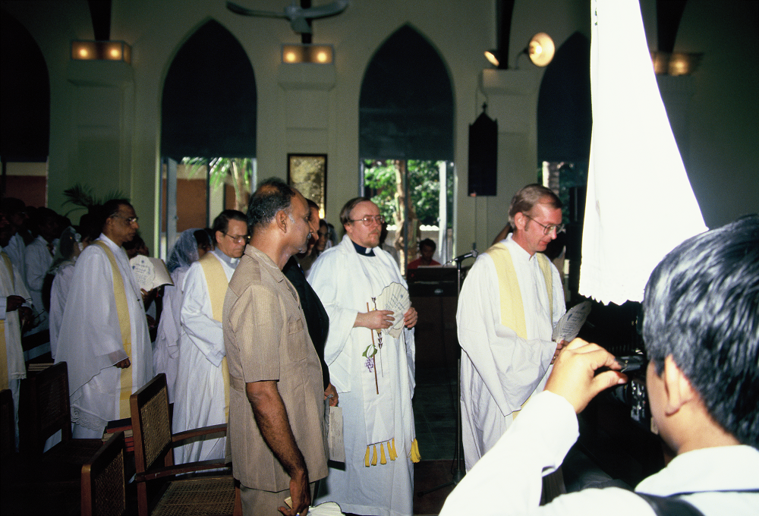Marching in. On the left Rev. J.J. Andrews (Bethlehem Lutheran Church)
It was a day to be remembered well by me for many reasons. Since Andrew, as he wanted to be called, had been the General Secretary of the Burma Council of Churches (BCC) which I had the duty to contact during my travels to Burma, I had met him some times before. In contrast to Rev. Andrews from the Lutheran Church, he had conveyed a different image of Burmese Christianity, an image of openness and integration into the country's mainstream society. On the occasion of one of my first visits he showed me around downtown Rangoon - the Ecumenical Sharing Centre on Pyi Rd. opposite Judson Church and the University had not been built and the Council's offices were located in the YMCA building on the corner of Maha Bandoola and Thein Byu streets. Andrew introduced me to some artists and art galleries and was obviously well connected with people from different professional and religious backgrounds. I wondered at the beginning of the service in the Cathedral if this worldly air could still be recognised within the context of a very solemn and traditional Anglican church ceremony. It could. I had the feeling that the new bishop was to open a new chapter of his church's social and societal commitment. Such feeling was increased by the events that had just happened in Rangoon. In March, student protests had begun that later should lead to a huge public uprising and the end of the Burmese Way to Socialism. Neither in the service nor in the subsequent meetings were such hot political topics directly addressed, but in retrospect I had the feeling that Bishop Andrews was the right man to deal with the new challenges lying ahead.
On later occasions I learned about other people's sceptical assessment of the Archbishop's policies that are mentioned in a general sense in the biography written by his sister. For many, both Burmese and foreigners, he seemed to act a little bit too worldly. But I enjoyed visiting him even after his retirement and my farewell from my pastoral duties in Southeast Asia. One of our last encounters was similar to the one described above. We had a cup of tea in a small restaurant near Kandawgyi Lake together with two other Burmese writers who were close friends of him. We talked about politics, literature and the different worlds we lived in. I liked it very much and felt very sad that I could not make it to attend his funeral in 2006.
On this background, I did some special editing on the biography passed on to us. I tried to omit some passages of the text stressing the qualities and achievements of the late bishop and substituted the “Special Prayer” at the end of Prof. Khin's biography with one of his poems.
These personal reflections can be summarised by the statement that it was and is exciting as well as challenging to meet a number of “strange friends”, both in the Christians portrayed in the biographies and the ways in which the biographers presented the life stories. More dialogues on formal and informal levels are surely needed to bridge the gaps between the different worlds of German and Myanmar versions of Christianity. Finally, I realise that our biography project is still incomplete unless we Germans try to present biographies of German Christians to our friends abroad. I guess they might be amazed as well by what they get. But until now there has not yet been any demand for such a next round of an encounter between our strange worlds.

For details see Hans-Bernd Zöllner, Opening the Market. Some reflections on the emergence of new Lutheran Churches in Myanmar (http://www.zoellner-online.org/material/opening-the-m
Alan Saw U 2004 Professor U Pe Maung Tin. A Gentle Genius. A Meek Master. Journal of Burma Studies 9: 35-42.
Particia Herbert 2004 U Pe Maung Tin Bibliography. Journal of Burma Studies 9: 130-176.
Universities Historical Research Centre 1999 U Pe Maung Tin. A Tribute. Yangon.
Herbert 2004: 134.

